INTERNSHIP REPORT

Submitted by

AKSHITA SHARMA [RA2211026010268]

Under the guidance of

Meeraj Kanaparthi
Engineering Manager, Staff Engineer at
Evernorth Health Services
Duration(6 months)
In partial fulfilment of the requirements for the degree of

BACHELOR OF TECHNOLOGY
in
COMPUTER SCIENCE AND ENGINEERING

with a specialization in

Artificial Intelligence and Machine learning


DEPARTMENT OF COMPUTATIONAL INTELLIGENCE

COLLEGE OF ENGINEERING AND TECHNOLOGY SRM INSTITUTE OF SCIENCE AND TECHNOLOGY KATTANKULATHUR – 603 203,

MAY 2026
Department of COMPUTATIONAL iNTELLIGENCE
SRM Institute of Science and Technology
OWN WORK DECLARATION FORM

Degree/ Course : B. Tech in Computer Science and Engineering with
specialization in Artificial Intelligence and Machine Learning.
Student Name : Akshita Sharma
Registration Number : RA2211026010268
Title of Work : HIH INTERN
I hereby certify that this assessment compiles with the University’s Rules and Regulations relating to Academic misconduct and plagiarism, as listed in the University Website, Regulations, and the Education Committee guidelines.
I confirm that all the work contained in this assessment is my own except where indicated, and that I have met the following conditions:
- Clearly references / listed all sources as appropriate
- Referenced and put in inverted commas all quoted text (from books, web, etc.)
- Given the sources of all pictures, data etc. that are not my own
- Not made any use of the report(s) or essay(s) of any other student(s) either past or present
- Acknowledged in appropriate places any help that I have received from others (e.g. fellow students, technicians, statisticians, external sources)
- Compiled with any other plagiarism criteria specified in the Course handbook / University website
DECLARATION:
We are aware of and understand the University’s policy on Academic misconduct and plagiarism and we certify that this assessment is my own work, except were indicated by referring, and that I have followed the good academic practices noted above.
AKSHITA SHARMA (RA2211026010268)

I understand that any false claim for this work will be penalised in accordance with the University policies and regulations.

SRM INSTITUTE OF SCIENCE AND TECHNOLOGY KATTANKULATHUR – 603 203

BONAFIDE CERTIFICATE

Certified that the “21CSP403L - INTERNSHIP REPORT” is the bonafide work of AKSHITA SHARMA [RA2211026010268], who carried out the internship work under my supervision. Certified further, that to the best of my knowledge, the work reported herein does not form part of any other thesis or dissertation on the basis of which a degree or award was conferred on an earlier occasion for this or any other candidate.

Dr. Siva R Dr. Annie Uthra
Associate Professor Professor and Head
Department of Computational Department of Computational
Intelligence Intelligence
SRM Institute of Science SRM Institute of Science
and Technology and Technology

ACKNOWLEDGEMENTS
We express our humble gratitude to Dr. C. Muthamizhchelvan, Vice-Chancellor, SRM Institute of Science and Technology, for the facilities extended for the project work and his continued support.

We extend our sincere thanks to Dr. Leenus Jesu Martin M, Dean-CET, SRM Institute of Science and Technology, for his invaluable support.

We wish to thank Dr. Revathi Venkataraman, Professor and Chairperson, School of Computing, SRM Institute of Science and Technology, for her support throughout the project work.

We encompass our sincere thanks to, Dr. M. Pushpalatha, Professor and Associate Chairperson - CS, School of Computing and Dr. Lakshmi, Professor and Associate Chairperson -AI, School of Computing, SRM Institute of Science and Technology, for their invaluable support.

We are incredibly grateful to our Head of the Department, Dr. Annie Uthra, Department of Networking and Communications, SRM Institute of Science and Technology, for her suggestions and encouragement at all the stages of the project work.

We want to convey our thanks to our Project Coordinators, Panel Head, and Panel Members Department of Computational Intelligence, SRM Institute of Science and Technology, for their inputs during the project reviews and support.

We register our immeasurable thanks to our Faculty Advisor, Dr. Nagendra Prabhu, Department of Networking and Communications, SRM Institute of Science and Technology, for leading and helping us to complete our course.

Our inexpressible respect and thanks to our guide, Dr. Siva R, Associate Professor, Cintel, SRM Institute of Science and Technology, for providing us with an opportunity to pursue our project under her mentorship. She provided us with the freedom and support to explore the research topics of our interest. Her passion for solving problems and making a difference in the world has always been inspiring.

We sincerely thank all the staff members of Department of Computational Intelligence, School of Computing, S.R.M Institute of Science and Technology, for their help during our project. Finally, we would like to thank our parents, family members, and friends for their unconditional love, constant support and encouragement.

INTERNSHIP OFFER LETTER
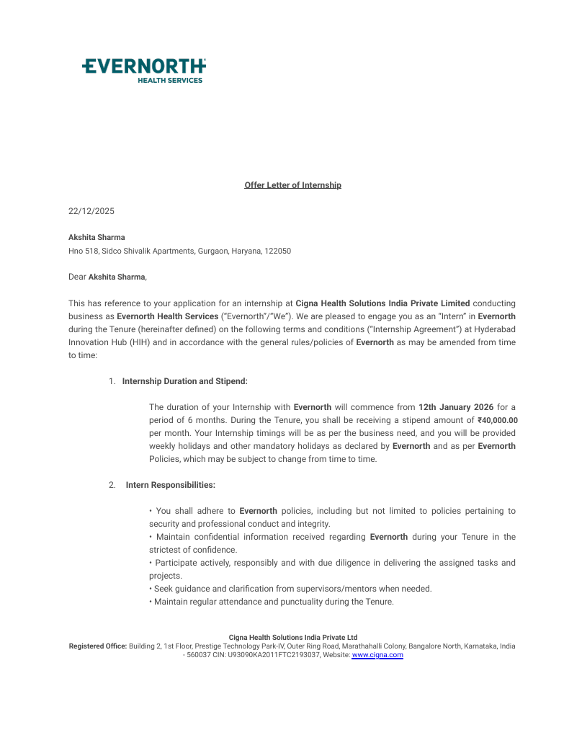

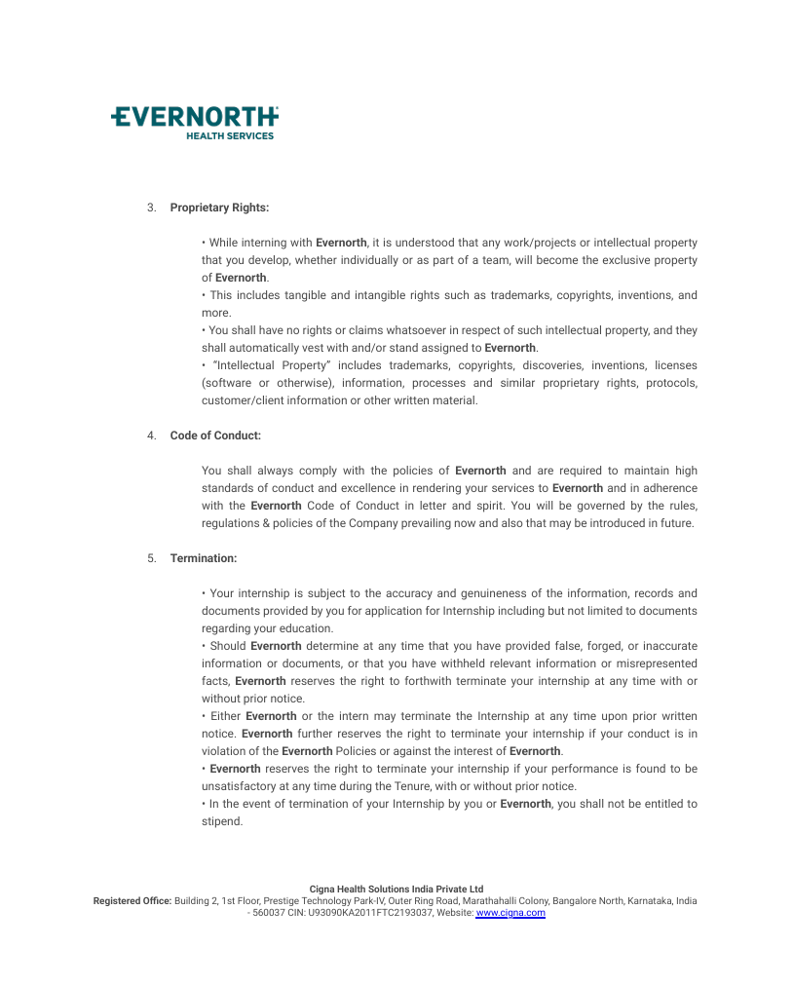

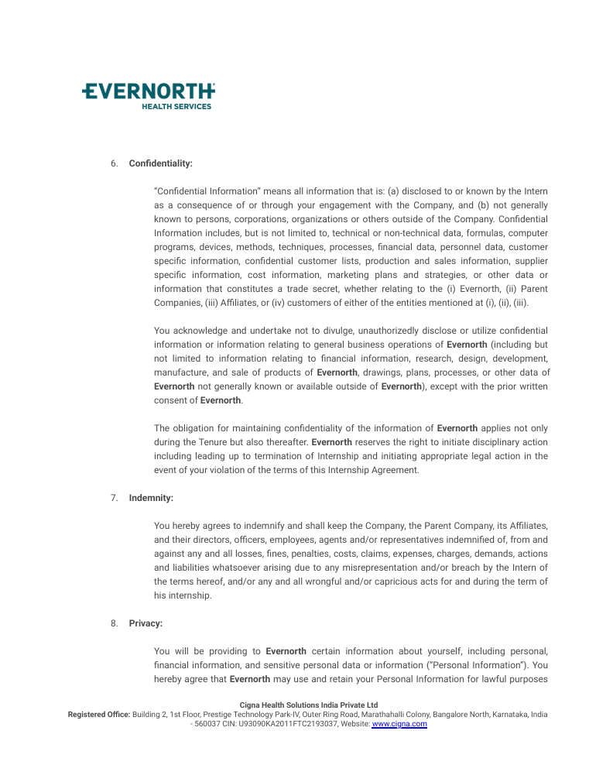
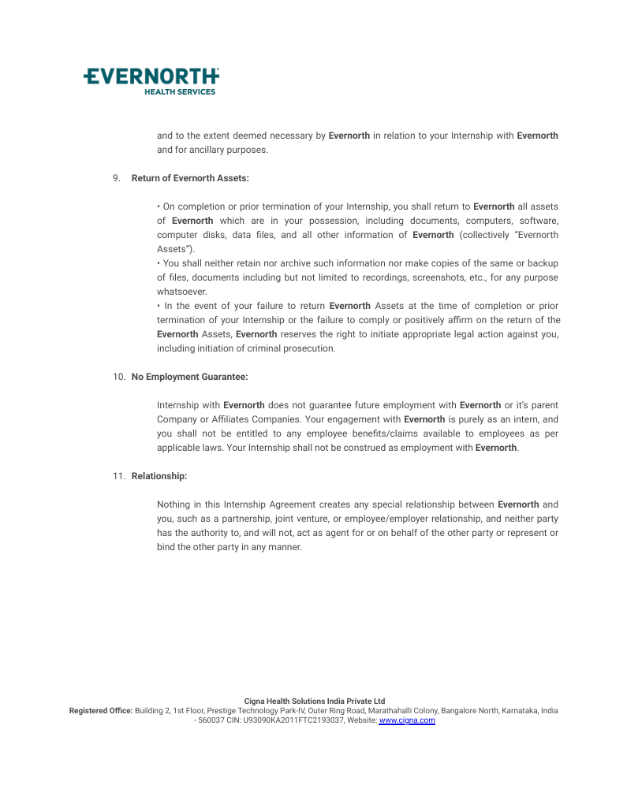

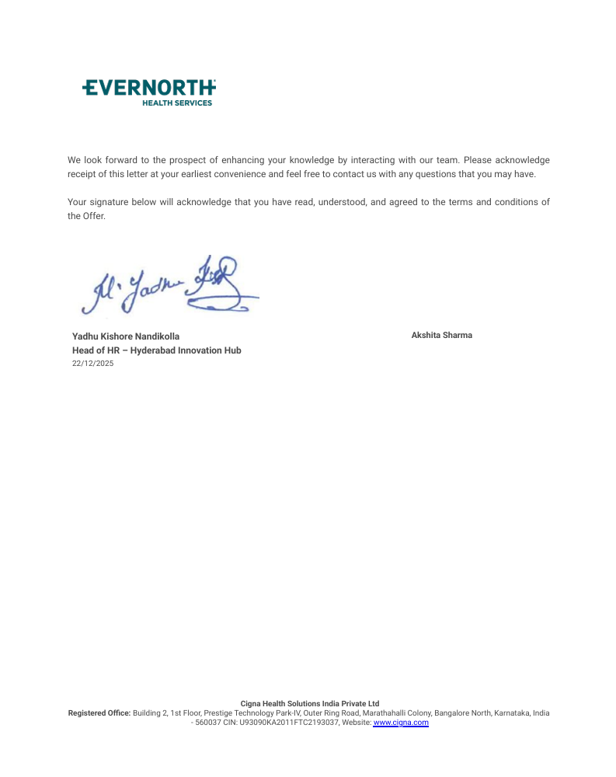

ABSTRACT

This report documents the technical work carried out during an internship in the Digital Engineering division of Evernorth Health Services. The role involved working as part of a globally distributed team spanning India and the United States, with the primary focus on applying modern full-stack technologies — including Angular, Python with FastAPI, and PostgreSQL — to address real organizational challenges through automation, data engineering, and gamification.The centerpiece of the technical work was SMART, an AI-powered JIRA Agent built to streamline agile ceremonies. By integrating with Microsoft Teams during Daily Stand-Up meetings, SMART processes natural language input to assess project statuses and update JIRA boards in real time, substantially reducing the administrative load on engineering teams and improving overall development velocity. Additional contributions included CTube, a video analytics platform with a custom recommendation engine; DeskHopper, a full-featured workplace management tool that uses QR-based check-ins and IoT-driven occupancy tracking; and OrgScape, a gamification layer that maps JIRA productivity data onto an interactive corporate hierarchy. Across all projects, Locust was used for performance and concurrency testing, and Bruno supported collaborative API documentation. Together, these systems advanced internal operational efficiency and offer a scalable base for future digital health innovations.

TABLE OF CONTENTS

ACKNOWLEDGEMENTS V
ABSTRACT VI
LIST OF FIGURES VII
1. INTRODUTION 17
1.1 Introduction 17
1.2 Domain Overview 17
1.3 Company Overview 18
1.4 Client Overview 19
1.5 Team Overview 20
1.6 Functional Module 21

2. PROJECT DESCRIPTION 22
2.1 Sprint 22
2.2 Projects Worked on 22
2.2.1 Ctube 22
2.2.2 Desk Hopper 23
2.2.3 Orgscape 23

3. SOFTWARE REQUIREMENTS SPECIFICATIONS 24
3.1 Software Requirements 24
3.2 Hardware Requirements 24
3.3 Functional Requirements 25
3.4 Non-Functional Requirements 25

4. TECNOLOGY 26
4.1 Jenkins 26
4.2 Coding Agent (Copilot & Claude) 26
4.3 Frameworks and Libraries 27
4.4 Version Control and Testing 27
4.5 Database (CockroachDB & PostgresSQL) 27

5. CODING 28
6. SCREENSHOTS 32
7. CONCLUSION 33
8. BIBILIOGRAPHY 34

CHAPTER 1

INTRODUCTION

1.1 Introduction
Evernorth Health Services operates as The Cigna Group's dedicated health services arm, built around a straightforward but ambitious idea: that healthcare works better when its moving parts talk to each other. In a sector where patients routinely navigate disconnected systems — separate portals for pharmacy, specialist care, and behavioral health — Evernorth was structured specifically to bridge those gaps. Rather than functioning as a closed network tied exclusively to Cigna-insured members, the organization runs as an open platform, meaning any health plan, employer, or government body can access its capabilities regardless of their primary insurer.
What distinguishes Evernorth from a conventional health services company is the depth of its integration. Brands like Express Scripts, Accredo, and MDLIVE sit under its umbrella not merely for branding purposes but because their data pipelines are deliberately connected. A pharmacist reviewing a specialty drug shipment through Accredo, for instance, can access behavioral health context from MDLIVE or claims history from Express Scripts — all within a single coordinated view of the patient. This "whole-person" approach to data is central to how the organization manages the most persistent pressure points in modern healthcare: unpredictable costs, opaque pricing, and treatment plans that miss the broader picture.
The organization employs thousands of clinical professionals — physicians, pharmacists, and nurses — working alongside data scientists whose primary job is to identify risk before it escalates. Predictive models scan member data to flag patients likely to experience a health crisis, triggering proactive outreach well before an emergency room visit becomes necessary. This combination of clinical depth and technology infrastructure positions Evernorth less as a vendor and more as an embedded partner in the healthcare delivery process.

1.2 Domain Overview
The health services domain Evernorth operates in sits at the intersection of pharmacy benefit management, specialty pharmacy distribution, and direct care delivery. Organizations in this space act as intermediaries — coordinating between drug manufacturers, insurance carriers, and patients — with the goal of making treatments accessible without allowing costs to spiral out of control.
Specialty pharmacy has become the dominant force reshaping this domain. Patients dealing with oncology, rare diseases, and complex autoimmune conditions require biologics and gene therapies that come with strict cold-chain requirements and high price tags. These medications now represent a growing share of total healthcare expenditure — exceeding fifty percent for many payers — and their management requires a level of clinical oversight and logistical precision that generic pharmacy operations simply cannot provide.
Technology has moved from a supporting role to a central one. Sophisticated algorithms handle drug interaction checks, risk scoring, and automated prescription fulfillment at volumes that would overwhelm purely manual systems. Digital health platforms have introduced the concept of whole-person care — synthesizing behavioral, physical, and social health data into a single patient profile — moving the industry away from transaction-based pharmacy services toward something closer to ongoing health management.
Competition in this market is concentrated among a small group of large players. Employers and government entities, feeling sustained pressure from rising healthcare spend, are pushing these organizations toward more transparent pricing structures and value-based arrangements. One particularly visible example is the demand for cost-protection programs around GLP-1 medications, where the financial exposure for plan sponsors has grown significant enough to require formal guarantees from service providers.
Federal and state regulations set the operational boundaries for everyone in the space. Medicare and Medicaid compliance requirements, HIPAA data privacy obligations, and evolving standards around health equity all shape how organizations like Evernorth design and deliver their services. Serving veterans, labor union members, and underserved communities requires benefit designs tailored to specific populations — a complexity that adds depth but also differentiation to what these organizations offer.

1.3 Company Overview
Evernorth Health Services was formally established in 2020 as a way to bring Cigna's growing portfolio of health service assets under a single, coordinated brand. As a wholly-owned subsidiary of The Cigna Group, it functions as the operational and innovation engine behind the parent company's health services revenues — an estimated $150 to $160 billion annually — while serving over 100 million people across its various platforms.
The company's portfolio spans several market-leading businesses. Express Scripts is among the largest pharmacy benefit managers in the United States, processing prescription claims for millions of members. Accredo handles the complex logistics and clinical oversight associated with specialty pharmacy. eviCore manages medical benefits, particularly prior authorization for high-cost procedures. MDLIVE provides 24/7 virtual care, connecting members with physicians and therapists without requiring an in-person visit. Together, these businesses allow Evernorth to offer point solutions for specific needs or a fully integrated service stack for clients who want everything managed in one place.
A defining aspect of the company's strategy is its open-market model. Evernorth does not restrict its services to Cigna-insured clients, which means it competes and wins business based on the quality of its offerings rather than captive relationships. This approach broadens the population it can serve and creates leverage for driving down costs through scale.
In 2024, Evernorth expanded its global footprint considerably with the opening of an innovation hub in Hyderabad, India. The facility serves as a center of excellence for software engineering, data analytics, and advanced technology development, including proprietary automation systems for specialty drug dispensing. The Hyderabad team works in close coordination with U.S.-based counterparts, contributing to a development model that keeps critical systems running and evolving around the clock.
Eric Palmer leads the organization as President and CEO, overseeing a workforce that spans clinical professionals, software engineers, data scientists, and operations specialists. The company's internal culture emphasizes collaboration across those disciplines, grounded in a stated commitment to diversity, equity, and the overall vitality of the populations it serves.

1.4 Client Overview
Evernorth's client base is deliberately diverse. The company works with health plans, large employers, government agencies, hospital systems, labor unions, and consulting firms — each engaging with the platform at a different level of integration. Some clients need a single capability, like pharmacy benefit management. Others want an end-to-end solution that covers pharmacy, medical management, and virtual care under one agreement.
Health plans and commercial employers form the largest segment. For health plans, Evernorth functions as an extension of their internal operations — providing data-driven tools to manage pharmacy and medical costs while generating clinical insights the plan's own team might not have the infrastructure to produce. Employers, including many in the Fortune 500, use Evernorth to design benefit packages that can serve workforces with varying income levels, geographic locations, and health needs. A practical example is the Digital Health Formulary, which evaluates and vets mobile health apps on behalf of employers, saving an estimated $100,000 to $120,000 per solution in implementation and assessment costs.
Government and public sector clients represent another significant portion of the business. Evernorth currently provides health benefit services to approximately 9.6 million federal beneficiaries, including active military personnel, veterans, and federal contractors. These clients operate under strict regulatory requirements and tight budget constraints, making waste reduction and administrative efficiency central to the value Evernorth delivers.
Hospital systems and consulting firms engage with Evernorth differently than payers do. Hospitals use Evernorth's analytics tools to benchmark their performance against peers and identify care delivery inefficiencies. Consultants draw on Evernorth's data capabilities when advising clients on benefit design strategy. Labor unions receive more customized support, with benefit structures built around the specific demographics and needs of their membership populations.
As of 2026, health equity has become a more prominent factor in client conversations. Plan sponsors are increasingly asking Evernorth to incorporate social determinants of health into care management — accounting for income, geography, and race when designing interventions. Programs like Embarc Benefit Protection address the financial side of this by providing cost guarantees for high-exposure categories like GLP-1 medications and gene therapies, giving clients a way to offer these treatments without taking on unbounded financial risk.

1.5 Team Overview
Evernorth's technology workforce is distributed across multiple countries, with major centers in the United States and India. Despite the geographic spread, teams operate in a unified development environment, using shared collaboration tools that allow an engineer in Hyderabad to work interchangeably with a product owner in St. Louis. This distributed model is practical rather than incidental — it supports round-the-clock development cycles on systems that power health services for millions of members.
The organization structures its technology functions across three broad areas. Clinical teams define care protocols and treatment rules. Operational teams manage the flow of pharmacy and medical benefits across the supply chain. Technology teams build the digital infrastructure that makes all of it work — spanning cloud architecture, cybersecurity, data science, and application development, all operating within an agile delivery framework.
Within this structure, the Digital Engineering Team focuses on building the next generation of internal tools. Rather than maintaining existing systems, this group takes on problems at the boundaries of what current technology can do — working primarily in AI, machine learning, and API integration to reduce the manual overhead embedded in everyday engineering workflows.
The team's current flagship project is called SMART, an AI-driven JIRA agent designed to automate scrum administration. The problem it addresses is familiar to any large software team: daily stand-up meetings generate a continuous stream of project updates — tasks completed, blockers identified, new requirements surfaced — but translating those verbal updates into accurate JIRA ticket changes requires manual effort that slows teams down and introduces errors.
SMART sits in on daily stand-up calls conducted through Microsoft Teams. Using natural language processing, it follows the conversation in real time, extracting references to specific tasks, statuses, and blockers. When a developer says a story is done, SMART moves the corresponding ticket. When a new requirement comes up, it creates a user story. The goal is to eliminate the gap between what gets said in a meeting and what actually gets updated in the project board — freeing engineers to focus on development rather than ticket maintenance.

1.6 Functional Module Overview
Evernorth's operational capabilities are organized into distinct functional modules, each designed to handle a specific layer of the health services stack. The modular design is deliberate — it allows clients to adopt specific capabilities without committing to a full platform migration, and it allows Evernorth to evolve individual components without disrupting the whole.
The Pharmacy Benefit Management and Specialty Pharmacy modules form the operational core. Express Scripts drives high-volume prescription processing, managing drug formularies, negotiating manufacturer rebates, and handling claims adjudication at scale. Accredo handles the more demanding work of specialty pharmacy — managing biologics that require temperature-controlled logistics, clinical monitoring, and ongoing patient contact to ensure adherence. Together, these two modules address both the cost and the quality dimensions of pharmaceutical care.
The Care Coordination and Virtual Delivery module, powered by MDLIVE and eviCore, manages patient access to the right care at the right time. It routes members toward cost-effective, clinically appropriate sites of care and handles the prior authorization processes that often create delays in treatment. Behavioral health sessions, virtual primary care visits, and specialist authorizations all run through this layer.
The Intelligence and Predictive Analytics module functions as the analytical foundation for everything else. It processes billions of data points — prescription claims, lab results, and social determinants of health — to generate risk scores and population health insights. When the system detects a pattern that suggests a patient is heading toward a health crisis, it triggers an alert to a care coordinator who can intervene before the situation worsens.
The Internal Productivity and Automation module houses the SMART AI agent and other tools that improve engineering efficiency. While the other modules are focused outward on patient and client outcomes, this module is focused inward — on the speed and accuracy of the development teams building those capabilities. By integrating AI agents into the tools engineers already use every day, this module reduces the administrative friction in the software development lifecycle, allowing the global engineering workforce to deliver updates and new features faster.

CHAPTER 2

SPRINT PLANNING AND EXECUTION

2.1 Sprint
Development during the internship followed an agile methodology structured around two-week sprint cycles. Each sprint had a defined scope established during a planning session at the start of the cycle, with tasks distributed among team members and tracked against a shared project board.
GitHub served as the primary tool for both sprint management and source control. Tasks were created as GitHub Issues, each containing a clear description, acceptance criteria, and any technical context needed to begin work. The Banking team maintained a dedicated GitHub Projects board — named simply "Banking" — where issues moved through columns representing their current state: To Do, In Progress, Done, and Invalid.
Sprint planning sessions happened at the beginning of each two-week cycle. The team reviewed the backlog, estimated effort for each task, and assigned work based on capacity and expertise. Progress was tracked continuously through the project board rather than waiting for end-of-sprint reviews. At the close of each sprint, a retrospective allowed the team to discuss what worked, what didn't, and what process changes might improve the next cycle. This rhythm of planning, execution, and reflection kept the team's output consistent and gave individual contributors a clear picture of where their work fit into the broader project.
2.2 Projects Worked On
The internship involved contributions to three distinct projects, each addressing a different operational or technical challenge within the organization. The work ranged from building data simulation environments to developing real-time booking infrastructure and gamification systems.

2.2.1 CTube – Video Analytics and Recommendation Platform
CTube was built as an internal video streaming and testing environment. The practical need was a controlled sandbox that could simulate the complexity of a real content delivery network — useful for testing recommendation algorithms and API performance without relying on third-party platforms.
- Custom Data Generation Module: Designed and populated a large synthetic dataset mirroring real-world video metadata, including tags, view counts, engagement metrics, and watch-time history.
- Recommendation Engine Module: Built backend logic using collaborative filtering and content-based tagging to deliver personalized video suggestions based on stored user preference data.
- Application Testing Module: Created a dedicated interface for stress-testing frontend performance and backend API response times under simulated high-concurrency conditions.
- Content Management Module: Developed an administrative layer for manual and automated ingestion of video data, keeping the testing environment current and dynamic.

2.2.2 DeskHopper – Smart Workplace and Facility Management
DeskHopper is an end-to-end office management platform built for hybrid work environments. The core challenge it addresses is coordinating physical desk availability with team proximity preferences, while also maintaining visibility into facility health and compliance.
- QR-Based Authentication Module: Enables contactless check-ins by generating and scanning unique QR codes at individual workstations, confirming that a booking corresponds to a physical presence.
- Intelligent Booking Logic Module: The central reservation engine, handling preference-based and team-based desk assignments. It accounts for individual preferences — such as window seats or quiet areas — while keeping teams seated in proximity to each other.
- Facilities and Logistics Dashboard: A management interface giving the facilities team real-time visibility into desk utilization, resource allocation, and workstation health status.
- Incident Reporting Module: A user-facing feature allowing employees to flag workstation problems — broken hardware, connectivity issues — directly from the booking interface, routing the report to the maintenance team.
- Capacity Monitoring Module: Integrates with ID card tracking infrastructure to generate real-time occupancy heatmaps, supporting compliance with building safety and capacity regulations.

2.2.3 OrgScape – Enterprise Hierarchy Gamification
OrgScape translates corporate structure into an interactive game environment, using real work output as the currency for in-game progression. The underlying idea is that making performance metrics visible and competitive through a game format increases engagement and creates positive reinforcement for productivity.
- Hierarchical Visualization Module: Maps the organization into a visual village-and-clan metaphor. Programs are rendered as villages; individual teams within those programs are shown as distinct clans with their own territory.
- JIRA API Integration Module: A live data pipeline pulling sprint velocity, ticket completions, and task progress from JIRA and converting those metrics into in-game experience points.
- Resource and Village Modification Module: Allows teams to spend their accumulated experience points on upgrades to their in-game village — structures, cosmetic enhancements, and functional improvements.
- Game Mechanics Module: Implements competitive gameplay modes, including battle and shape-shifting mechanics, allowing teams to engage in performance-based competition against each other.
- Identity and Employee Profile Module: Renders individual employees as avatars within their clan, displaying contribution history, achievement badges, and current experience point standing.

CHAPTER 3

SOFTWARE REQUIREMENTS SPECIFICATIONS

3.1 Software Requirements
The development stack was selected for performance, maintainability, and compatibility with the organization's existing infrastructure.
- Frontend Framework: Angular (v14+) was used for building the user interfaces across DeskHopper and OrgScape, providing a structured component architecture suited to complex, multi-view applications.
- Backend Framework: Python 3.10+ with FastAPI handled all server-side logic. FastAPI's asynchronous capabilities and automatic OpenAPI documentation made it a practical fit for the project's requirements.
- Database Management: PostgreSQL was used as the primary relational database, chosen for its reliability, support for complex queries, and transactional integrity.
- API Testing: Bruno served as the API client for testing and documenting endpoints. Its Git-friendly format meant API collections could be stored directly in the repository, simplifying collaboration.
- Version Control: Git, accessed through GitHub and GitLab, managed source code, branch strategy, and peer code reviews across the team.
- Performance Testing: Locust was used for load and concurrency testing, allowing the team to write test scenarios in Python and simulate thousands of simultaneous users.

3.2 Hardware Requirements
- Development Machine: A minimum hexa-core processor — Intel i7 or AMD Ryzen 7 equivalent — to handle parallel execution of Angular development servers and FastAPI backend processes.
- Memory: 16GB RAM at minimum, with 32GB recommended to support concurrent Docker containers, IDEs, and browser-based testing without performance degradation.
- Storage: 512GB NVMe SSD for fast I/O during database operations and Angular build compilation.
- Network: High-speed broadband to support remote collaboration between Hyderabad and global offices, and for accessing cloud-based JIRA APIs and internal code repositories.

3.3 Functional Requirements
- Automated Project Management: The SMART agent must intercept Microsoft Teams audio and text during daily stand-ups, and automatically create, update, or transition JIRA stories based on what is discussed.
- Workplace Orchestration: DeskHopper must provide a real-time booking interface where users can reserve desks by team proximity preference and use QR codes for physical attendance confirmation.
- Data Simulation: CTube must deliver a working recommendation engine that generates content suggestions based on user preference patterns stored in the custom synthetic dataset.
- Dynamic Visualization: OrgScape must pull live data from the JIRA API and render it as an updated gamified hierarchy, reflecting changes in experience points and village status as tasks are completed.
- Administrative Control: Facilities and HR teams must have access to dashboards showing real-time office occupancy and sprint task completion rates.

3.4 Non-Functional Requirements
- Scalability: System architecture must support high concurrent user volumes, validated through Locust testing against peak booking and stand-up activity scenarios.
- Performance: API response times must stay below 200ms for standard CRUD operations to maintain a smooth experience in the Angular frontend.
- Reliability: PostgreSQL transactional integrity must prevent double-booking of desks and data loss during JIRA experience point updates.
- Maintainability: Code must follow clean architecture patterns in both FastAPI and Angular, with API collections committed to the repository via Bruno for straightforward developer onboarding.
- Security: All applications must use secure authentication for employee logins, and JIRA API tokens must be managed through environment variables rather than hardcoded values.

CHAPTER 4

TECHNOLOGY

The development and deployment of these projects relied on a sophisticated, enterprise-grade technology stack. The following tools and frameworks were instrumental in achieving the performance and scalability requirements of Evernorth Health Services.

4.1 Continuous Integration and Deployment – Jenkins
Jenkins handled the CI/CD pipeline across all three projects. Every code commit triggered automated test execution and, on success, deployment to the staging environment. Managing pipeline scripts through Jenkins ensured that the build process remained consistent regardless of which developer had committed the change, and it prevented untested code from reaching shared environments. Jenkins also coordinated the sequential deployment of Angular frontends and FastAPI backends, maintaining environment parity throughout the development cycle.

4.2 AI Coding Assistants – GitHub Copilot and Cursor
Two AI tools were integrated into the daily development workflow to improve output speed without compromising code quality.
GitHub Copilot provided inline suggestions during coding sessions — particularly useful for generating boilerplate Angular components and completing repetitive implementation patterns. Cursor was used as a full IDE environment for tasks requiring deeper reasoning: refactoring large code blocks, detecting subtle bugs, and rapidly prototyping logic for the SMART agent. Both tools shifted the day-to-day focus from syntax-level concerns toward higher-level architectural decisions.

4.3 Frameworks and Libraries – Angular, FastAPI, and Phaser
Angular provided the structural foundation for the frontend applications. Its component-based architecture suited both the DeskHopper dashboard — which required a complex, state-driven interface — and the CTube UI, which needed clean separation between recommendation display and content management views.
FastAPI managed all backend processing, handling JIRA API integration, real-time data transformation, and the high volume of concurrent requests generated during load testing. Its native support for asynchronous operations was a practical requirement given the concurrency targets established in the non-functional requirements.
Phaser was used exclusively for OrgScape. This HTML5 game framework rendered the two-dimensional village environments, managed avatar animations for individual employee profiles, and handled the real-time interactions in the battle mechanics module. It bridged the gap between conventional web application development and game logic in a way that a standard frontend framework would not have supported.

4.4 Version Control and Testing – Git, Bruno, and Locust
Git underpinned all version control activity, managing feature branches and coordinating code reviews across the globally distributed team. The branch strategy kept main environments stable while allowing parallel feature development without conflicts.
Bruno served as the team's API documentation and testing client. Unlike proprietary API tools, Bruno stores collections in a plain-text, Git-compatible format, which meant API tests lived alongside the application code in the repository. This made onboarding new team members considerably faster and kept documentation in sync with implementation.
Locust was used to validate performance requirements under realistic load conditions. Written in Python, Locust test scenarios simulated hundreds of concurrent users interacting with the booking system and SMART agent simultaneously, giving the team data to confirm that response time targets would hold under production-level traffic.

4.5 Database Management – PostgreSQL and CockroachDB
PostgreSQL served as the primary database for both CTube and DeskHopper. Its support for complex relational queries and strong transactional guarantees made it well suited for managing the interdependencies between users, desk bookings, and content metadata. Ensuring no two users could book the same desk simultaneously — a non-negotiable functional requirement — was handled through PostgreSQL's built-in transaction isolation.
CockroachDB was brought in for OrgScape, where the requirement was different. The gamification system needed to maintain consistent experience point records across geographically distributed users, with no tolerance for data loss during high-volume update bursts. CockroachDB's distributed SQL architecture addressed this by replicating data across regions, ensuring that a network disruption in one location would not corrupt or lose the state of another team's village

CHAPTER 5

Coding

const config = {
type: Phaser.AUTO,
width: 800,
height: 600,
backgroundColor: '#2d2d2d',
scene: {
create: create
}
};

const game = new Phaser.Game(config);

function create() {
const mapSize = 10; // 10x10 grid
const tileW = 64;
const tileH = 32;
const offsetX = 400; // Center the map horizontally
const offsetY = 100; // Offset from top

// Simple Map Data: 0=Ground, 1=Water, 2=Land, 3=House, 4=Human
const map = [
, , ,
, ,
,
,
,
,

];

const colors = {
ground: 0x7cfc00, // Grass Green
water: 0x00bfff, // Deep Sky Blue
land: 0xdeb887, // Burlywood (Dirt)
house: 0xff4500, // OrangeRed
human: 0xffffff // White
};

for (let y = 0; y < mapSize; y++) {
for (let x = 0; x < mapSize; x++) {

// Calculate Isometric Position
let tx = (x - y) * (tileW / 2) + offsetX;
let ty = (x + y) * (tileH / 2) + offsetY;

let type = map[y][x];
let color = colors.ground;
if (type === 1) color = colors.water;
if (type === 2 || type === 3) color = colors.land; // Houses sit on land

// Draw the Base Tile (Diamond shape)
let tile = this.add.graphics();
tile.fillStyle(color, 1);
tile.beginPath();
tile.moveTo(0, tileH / 2); // Left
tile.lineTo(tileW / 2, 0); // Top
tile.lineTo(tileW, tileH / 2); // Right
tile.lineTo(tileW / 2, tileH); // Bottom
tile.closePath();
tile.fillPath();
tile.setPosition(tx - tileW / 2, ty);

// Add Structures (Houses or Humans)
if (type === 3) {
// Draw a simple box for a house
let house = this.add.graphics();
house.fillStyle(colors.house, 1);
house.fillRect(-10, -30, 20, 30); // Simple rectangle "building"
house.lineStyle(2, 0x000000, 0.5);
house.strokeRect(-10, -30, 20, 30);
house.setPosition(tx, ty + tileH / 2);
}
else if (type === 4) {
// Draw a simple cylinder/stick for a human
let human = this.add.graphics();
human.fillStyle(colors.human, 1);
human.fillCircle(0, -25, 5); // Head
human.fillRect(-2, -20, 4, 20); // Body
human.setPosition(tx, ty + tileH / 2);
}
}
}
}

CHAPTER 6

Screenshots

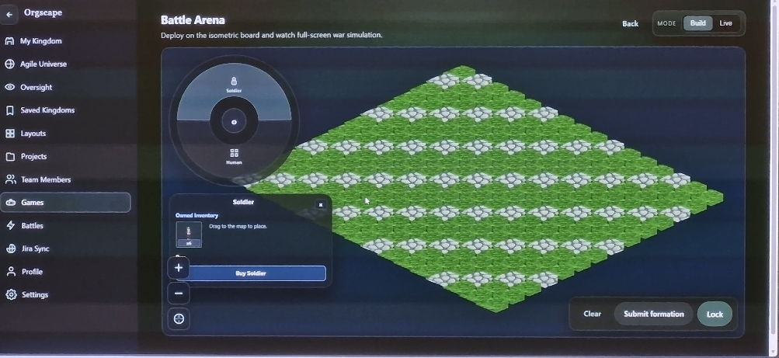
Fig 1. Orgscape Battle Arena

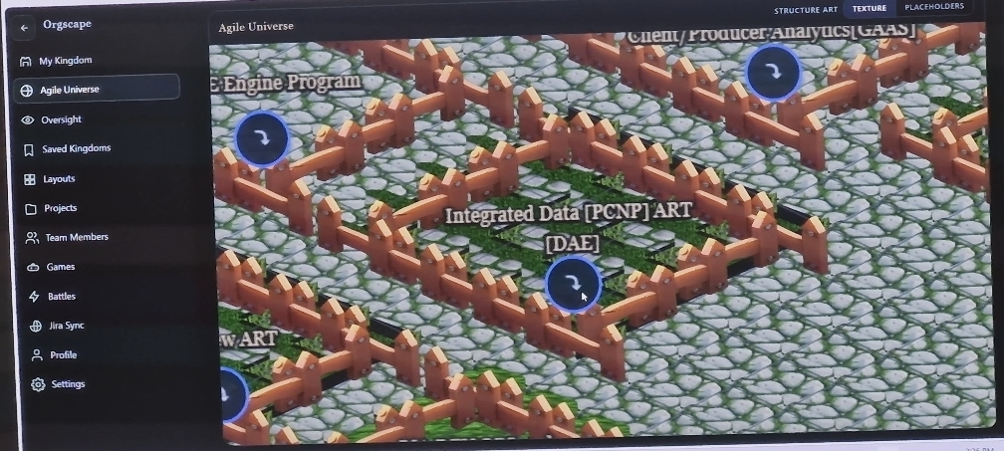
Fig 2. Orgscape Agile Universe

CHAPTER 7

CONCLUSION

The internship at Evernorth Health Services turned out to be far more than an introduction to enterprise software development — it was a hands-on education in what it actually takes to build systems that work at scale, across time zones, and under real constraints. Working within the Digital Engineering team meant being part of something genuinely operational: the tools built here were not prototypes or sandbox exercises, but production-grade applications used by engineers across India and the United States on a daily basis. That sense of real stakes shaped every technical decision made throughout the tenure.
The SMART AI Agent perhaps best captures what this experience was about. The problem it addressed — the quiet, persistent inefficiency of manually transcribing meeting outcomes into JIRA — was easy to overlook, yet the friction it caused was felt by every engineer on the team. Designing a system that could listen to Daily Stand-Ups, interpret what was said, and autonomously reflect those updates on the board required more than just connecting a few APIs. It demanded careful thinking about edge cases, tolerance for ambiguity in spoken language, and a commitment to getting the user experience right so that adoption would actually happen. Watching it function smoothly in a live meeting environment, week after week, was one of the more rewarding moments of the internship.
DeskHopper and OrgScape took a different approach to the same underlying question: how do you make a distributed workplace feel less fragmented? DeskHopper addressed the logistical side — giving people reliable, real-time visibility into office capacity so that hybrid workdays could be planned with confidence rather than guesswork. OrgScape took the motivational angle, asking whether the data already being generated through JIRA could be reframed in a way that encouraged engagement and healthy team competition. Both projects reinforced something that became clearer as the internship progressed: good software design is inseparable from a genuine understanding of how people actually work and what frustrates them.
On the technical side, the exposure to FastAPI's asynchronous architecture, Angular's component model, and the discipline of writing proper concurrency tests with Locust built a more complete picture of what production systems require. It is one thing to build something that works under normal conditions; it is another to know it will hold up when a hundred users hit it simultaneously. That distinction — between software that runs and software that is reliable — became a recurring theme across all the projects.
Looking back, the cumulative value of this internship lies not just in the features shipped or the tickets closed, but in the habits and instincts developed along the way: documenting APIs clearly so colleagues in other time zones could pick up the work, thinking about data models before writing a single line of controller logic, and understanding that the best technical solution is often the one that requires the least explanation to use. These are lessons that cannot be learned from a course outline, and Evernorth provided an environment where learning them felt natural. The foundation built here — in tools, in process, and in thinking — carries forward into whatever comes next.
CHAPTER 8

BIBILIOGRAPHY

Books / Academic References:
- Robert C. Martin, Clean Code: A Handbook of Agile Software Craftsmanship, Prentice Hall. Used for understanding best practices in writing clean, maintainable, and efficient code.
- Martin Fowler, Patterns of Enterprise Application Architecture, Addison-Wesley. Provided insights into backend system design, scalability, and architectural patterns used in enterprise applications.
- Sam Newman, Building Microservices, O’Reilly Media. Helped in understanding service-based architectures, API design, and distributed system concepts relevant to backend development.

Online Resources / Documentation:
- Jenkins Documentation – https://www.jenkins.io/doc/
Used for understanding CI/CD pipelines, automation workflows, and deployment processes.
- OpenSearch Documentation – https://opensearch.org/docs/
Reference for log analysis, monitoring, and debugging of backend systems.
- PostgreSQL Documentation – https://www.postgresql.org/docs/
Used for understanding database management, queries, and transaction handling.
- CockroachDB Documentation – https://www.cockroachlabs.com/docs/
Reference for distributed database systems, scalability, and fault tolerance.
- GitHub Documentation – https://docs.github.com/
Used for version control, issue tracking, and project management.

